Task 1 Create SSH Key Pair for Azure Virtual Machine
The Nautilus DevOps team is strategizing the migration of a portion of their infrastructure to the Azure cloud. Recognizing the scale of this undertaking, they have opted to approach the migration in incremental steps rather than as a single massive transition. To achieve this, they have segmented large tasks into smaller, more manageable units. This granular approach enables the team to execute the migration in gradual phases, ensuring smoother implementation and minimizing disruption to ongoing operations. By breaking down the migration into smaller tasks, the Nautilus DevOps team can systematically progress through each stage, allowing for better control, risk mitigation, and optimization of resources throughout the migration process.
For this task, create an SSH key pair with the following requirements:
• The name of the SSH key pair should be nautilus-kp.
• The key pair type must be rsa.

Solution
Create via script
Run:

az sshkey create \
--name nautilus-kp \
--resource-group kml_rg_main-f6f6f800e7cb43cb \
--encryption-type RSA

Then optionally confirm with:

az sshkey show \
--name nautilus-kp \
--resource-group kml_rg_main-f6f6f800e7cb43cb

From portal
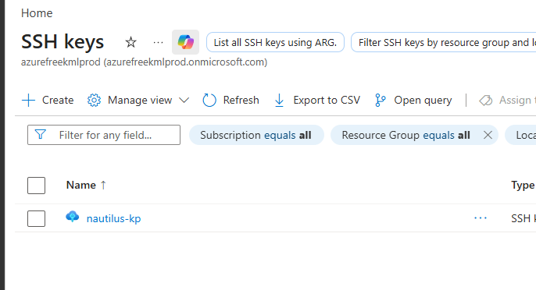
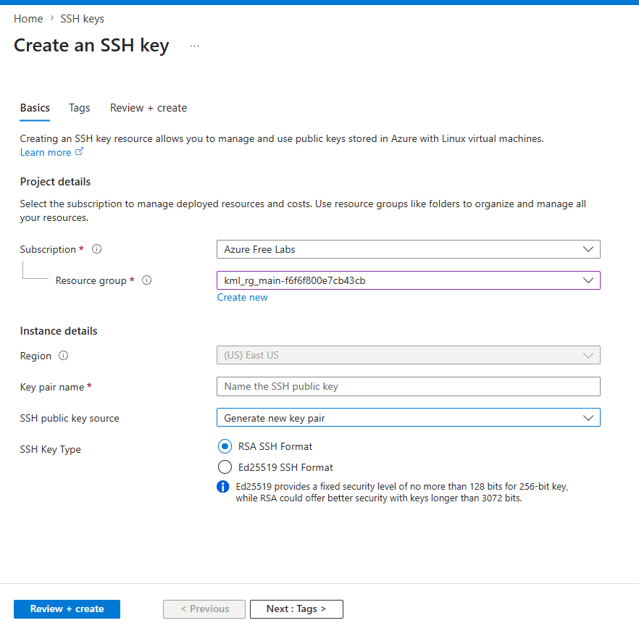

Why we need that
The SSH key pair is needed to securely access Azure Linux virtual machines using SSH. The public key is added to the VM, and the private key is used by the DevOps team to authenticate without a password.

Task 2 Create an Azure Virtual Machine
The Nautilus DevOps team is planning to migrate a portion of their infrastructure to the Azure cloud incrementally. As part of this migration, you are tasked with creating an Azure Virtual Machine (VM).
The requirements are:
1) Use the existing resource group.
2) The VM name must be nautilus-vm, it should be in eastus region.
3) Use the Ubuntu 24.04 LTS image for the VM.
4) The VM size must be Standard_B1s.
5) Attach a default Network Security Group (NSG) that allows inbound SSH (port 22).
6) Attach a 30 GB storage disk of type Standard HDD.
7) The rest of the configurations should remain as default.
After completing these steps, make sure you can SSH into the virtual machine.

Solution
From script
az sshkey create \
--name nautilus-kp \
--resource-group kml_rg_main-54265d203aa14a65 \
--location eastus

az vm create \
--resource-group kml_rg_main-54265d203aa14a65 \
--name nautilus-vm \
--location eastus \
--image Canonical:ubuntu-24_04-lts:server:latest \
--size Standard_B1s \
--admin-username azureuser \
--ssh-key-name nautilus-kp \
--nsg-rule SSH \
--os-disk-size-gb 30 \
--storage-sku Standard_LRS

az vm show \
--resource-group kml_rg_main-54265d203aa14a65 \
--name nautilus-vm \
-d \
--query publicIps \
-o tsv

From portal
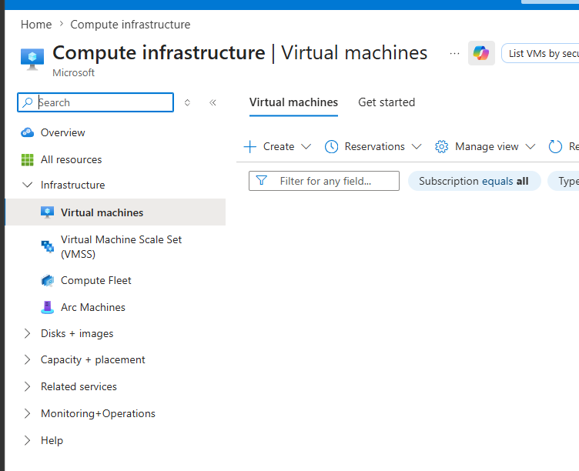

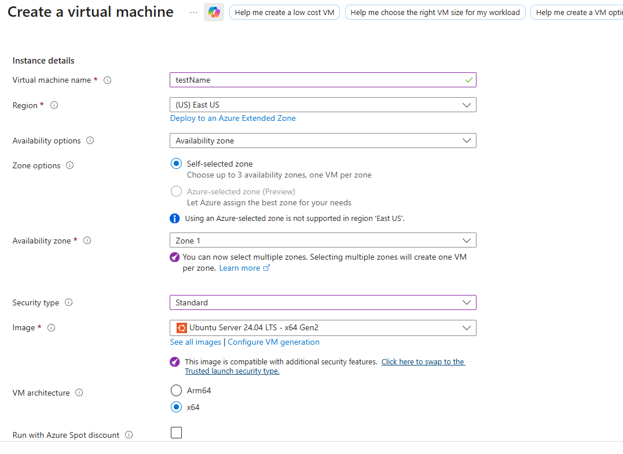
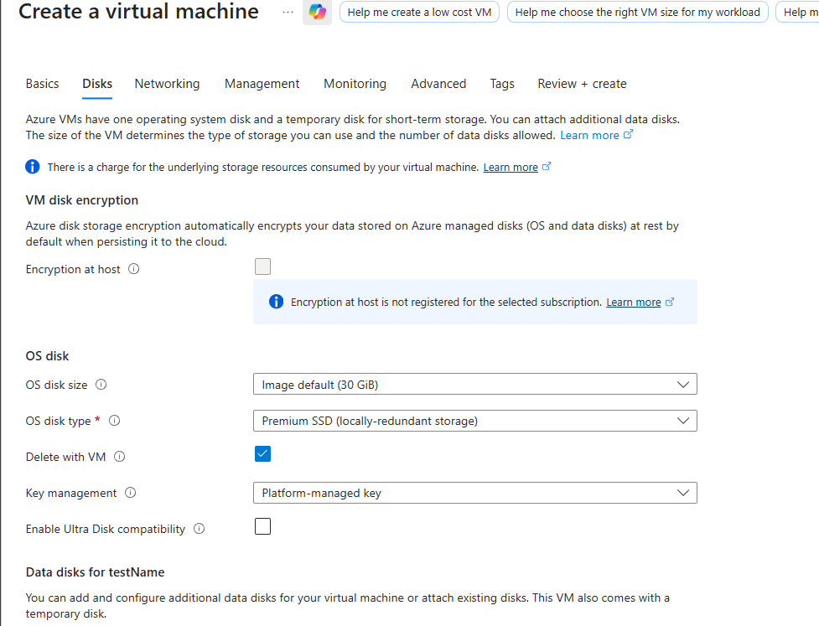

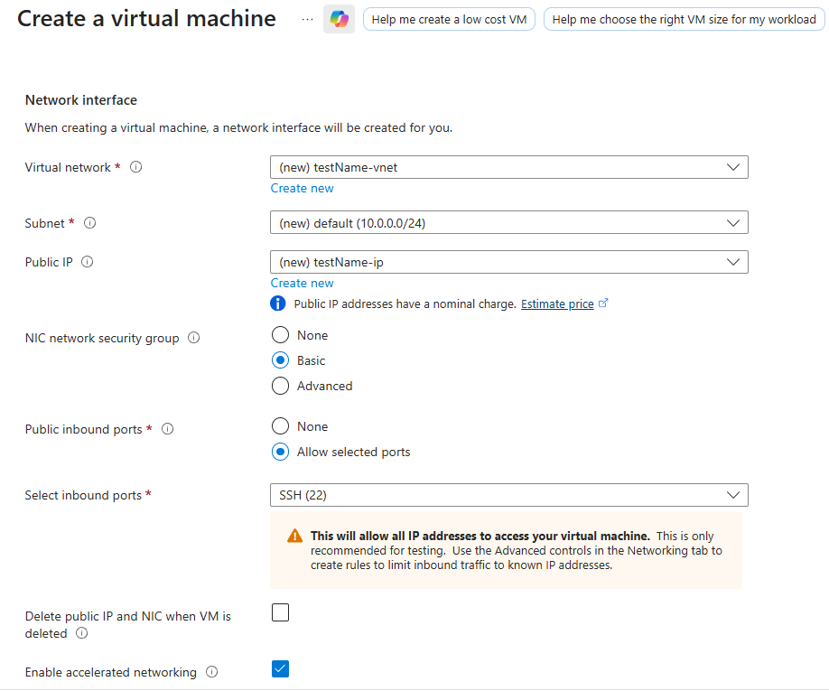

Why we need that
This VM was created to provide a Linux server in Azure for the Nautilus DevOps team’s migration. It gives them a cloud-based Ubuntu machine for deployment, testing, administration, and remote access over SSH while moving infrastructure in small steps.

